Quiz 01

- Consider silicon at 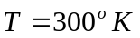doped with phosphorus at a concentration of 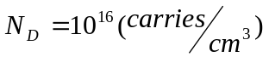. Calculate the thermal equilibrium electron and hole concentrations.
- Consider a silicon PN junction at doped at 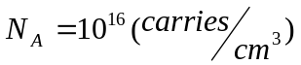 in the p-junction and 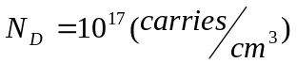 in the n-junction. Calculate the different potential at PN-junction.
- Consider a silicon PN junction at with doping concentration of and 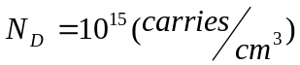. Assume 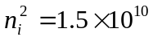 and let 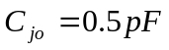. Calculate the junction capacitance at 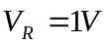 and 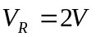.
- Consider a N-type silicon at with doping concentration of . Assume the charge density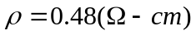. Find the mobility of electron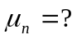.
- Consider the following three impure silicon semiconductor samples:

 | Doped B element | Doped P element
Sample A | Concentration 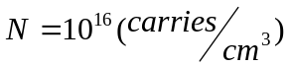
Sample B |  | Concentration
Sample C | Concentration | Concentration
Calculate the conductivity of these three samples.
(Hint: A sample doped at equivalent concentration of +5 and +3 elements may become intrinsic semi-conductor)

